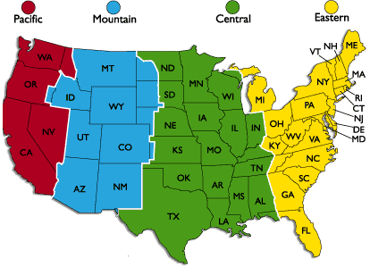Email orders to [parts@newwaytrucks.com](mailto:parts@newwaytrucks.com). Follow up orders placed at or near cutoff time with a phone call to assure order is placed in time.

**12:30 PM Ground**

**2:30 PM Air**

**11:30 AM Ground**

**2:30 PM Air**

**10:30 AM Ground**

**12:30 PM Air**

**ALASKA CUT OFF TIME**

**9:30 AM Ground.**

**11:30 AM Air**

**1:30 PM Ground**

**3:30 PM Air**

**HAWAII CUT OFF TIME**

**- 8:30 AM Ground**

**11:30 AM Air**

**PARTS CALL CENTER HOURS OF OPERATION**



